**Carl-X Client Installation with ITSi**

***Please Note: You must uninstall any Carl-X software from your workstation before performing these instructions.***

1. To begin the client installation, run the CarlX.exe. The current version installation file can be found at <https://melstage.tln.lib.mi.us/carlclient/CarlX.exe>
   1. The version number will not match the images in this document. Images are for reference only.

**2)** Click **Next>**

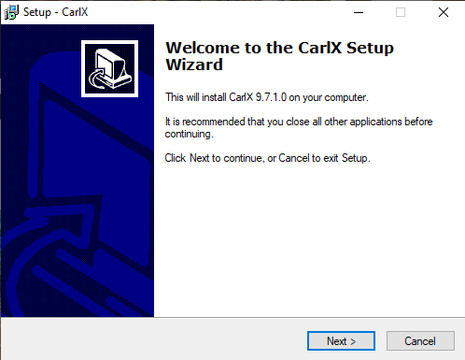

1. Select the **Live:** radio button then click **Next>**

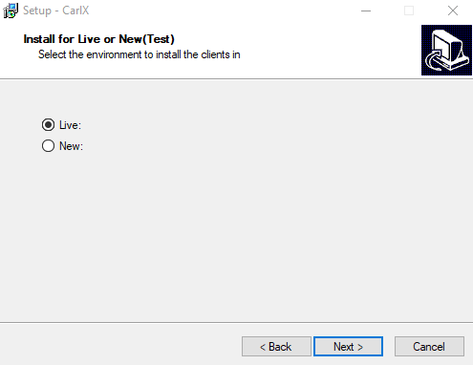

1. Ensure that ONLY the **Staff Workstation** and **Its Workstation** checkboxes are checked. You will not have access for the Admin Workstation.

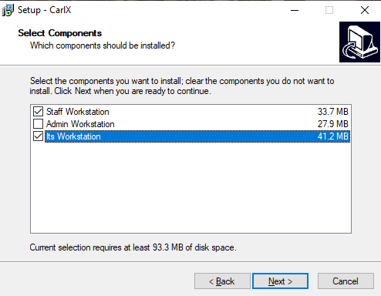

1. Input the connection settings based on the following information, then click **Next>** 
   1. Connection IP: tlnapp.tln.org
   2. Database Number (InstBit): 1720
   3. Branch Number: This field should be your delivery number, without any leading zeros
      * 1. Example: REDF_09 would enter 9 into this field
        2. Example: WHLK_73 would enter 73 into this field
        3. Example: BRIT_212 would enter 212 into this field

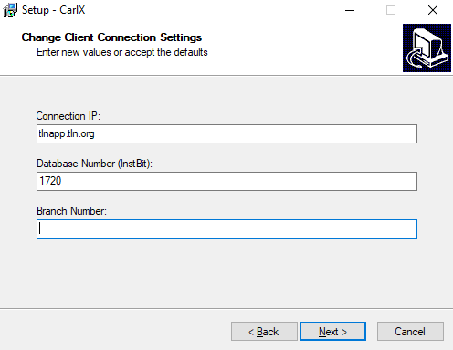

1. Ensure that the Phost Information is present with the following information. If the fields are not autofilled with the information, just type the data into the text boxes.
   1. Phost IP address: tlnapp.tln.org
   2. Phost Port Number: 2279

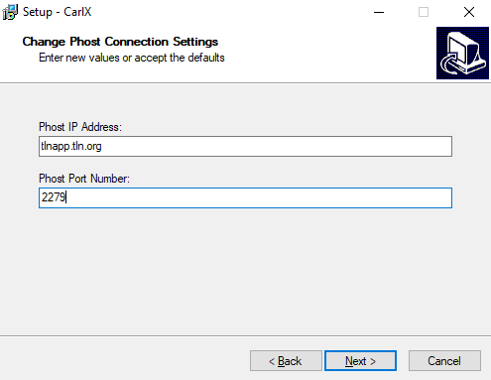

1. Ensure that the information on the review screen is correct. Please Note that the Phost IP may be blank on this review screen even though tlnapp.tln.org was entered. Branch number is the most important field to ensure is correct. Then click **Install**.
   1. If prompted to install the **Microsoft Visual C++ Redistributables** during the instation process, answer **Yes**

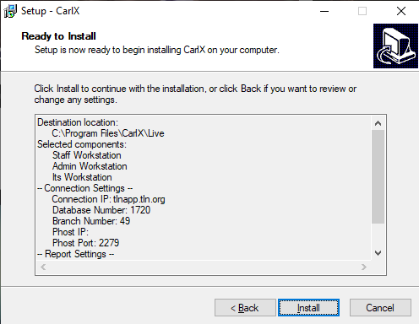

1. Click **Finish** to complete the installation of the Carl-X Staff Client.

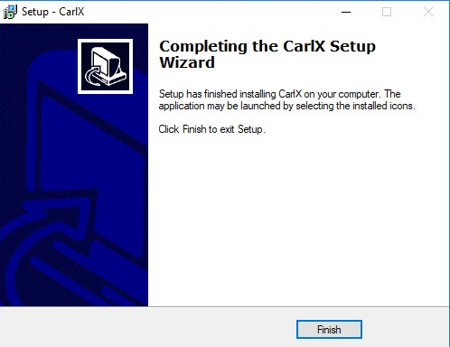

1. After the staff client installation is complete, you will need to copy the configuration file for your library to the Carl-X program folder (C:\Program Files\CarlX\Live). 
   1. Configuration files are maintained at the following location:
      1. <https://melstage.tln.lib.mi.us/carlclient/INI_Files/Cataloging>
      2. Right Click on the file and choose the **Save Link as** option
2. In addition to the Configuration file, a copy of the TLN Specific TEMPLATE File must be placed in the Carl-X program folder (C:\Program Files\CarlX\Live). This TEMPLATE file contains all of the TLN approved MARC Record Templates for bibliographic records added by member libraries.
   1. TEMPLATE File is maintained at the following location:
      1. <https://melstage.tln.lib.mi.us/carlclient/TEMPLATE_File/>
      2. Right Click on the file and choose the **Save Link as** option
      3. If prompted to overwrite the existing template file, please answer **YES**

1. The login that you will use when connecting to the Carl-X system will be as follows:

**a.** User Name: Your library 4 letter delivery code + the word cat

* + - * 1. Example: redfcat

**b.** The password for ITSi access will be provided when your library is trained on the use of the ITSi Client.